EXPERIMENT 2
EXPERIMENT OBJECTIVES :
Students will use Packet Tracer Simulation mode to observe how packets move between devices, how switches learn MAC addresses, and how ICMP echo request / reply travels through a small network.

AIM: Packet Flow Visualization Using Simulation Mode

INSTRUCTIONS:
TASK 1: Build a simple LAN
. 1 Switch + 3 PCs
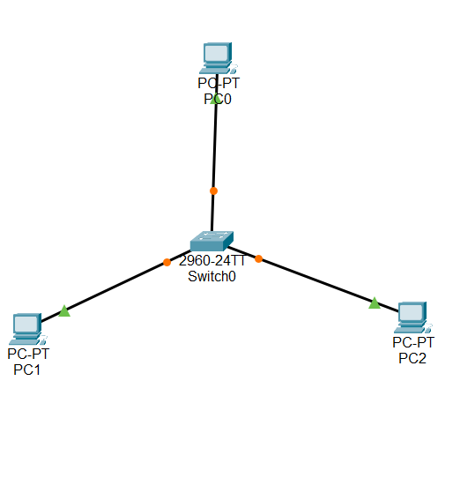

. IP example : 192.168.20.1-3/24
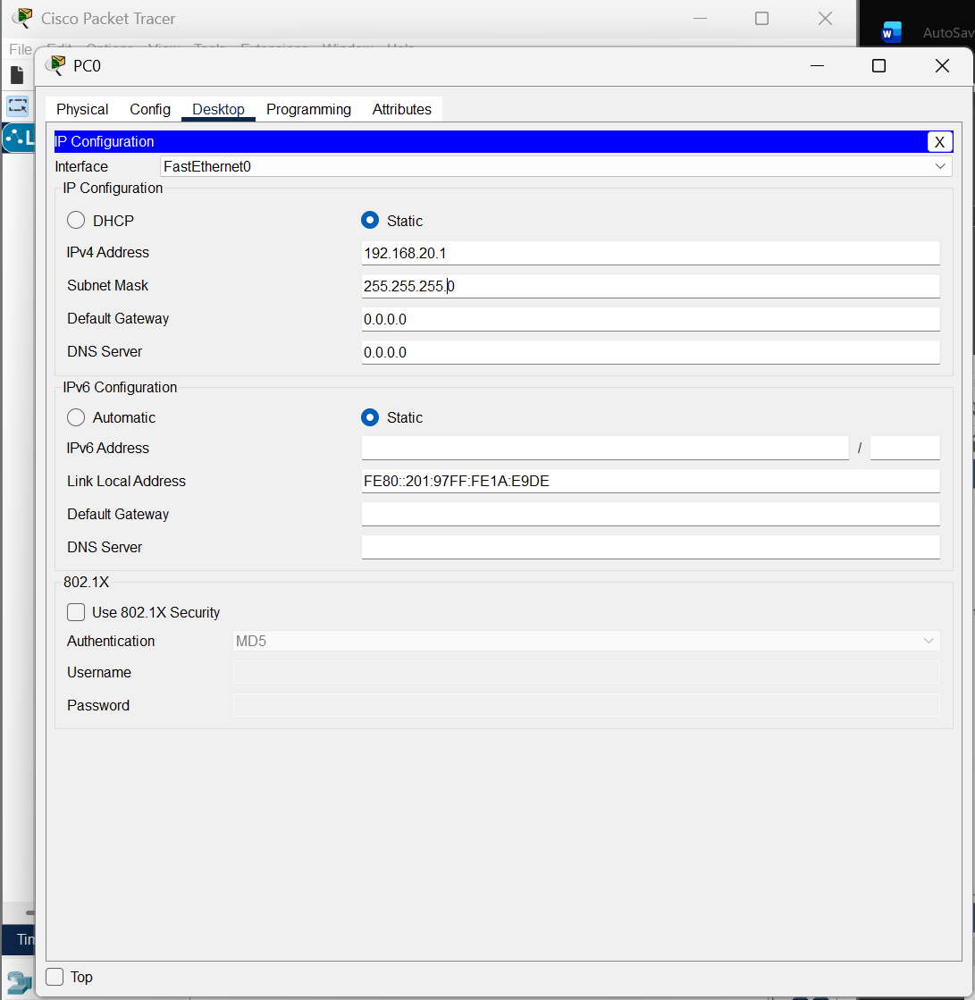

Task 2: First Ping Observation
- Enable Simulation Mode
- Ping PC1 → PC2
- Observe ARP request and ARP reply before ICMP

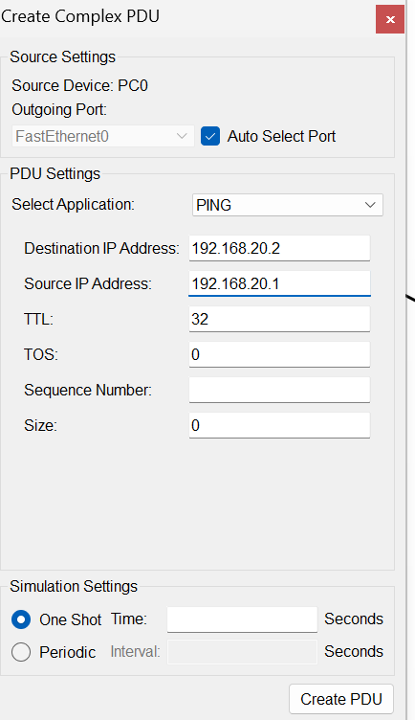
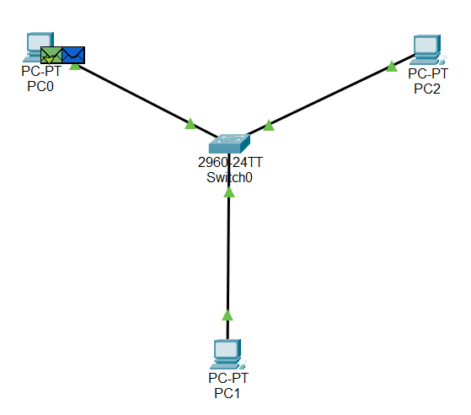
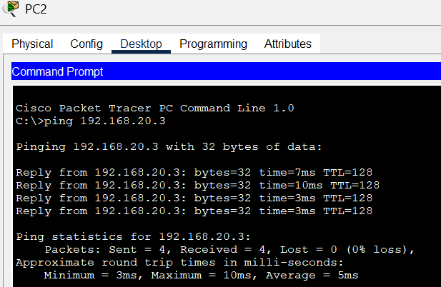

Task 3: Second Ping Observation
- Ping PC1 → PC2 again
- Observe fewer packets (ARP cached)

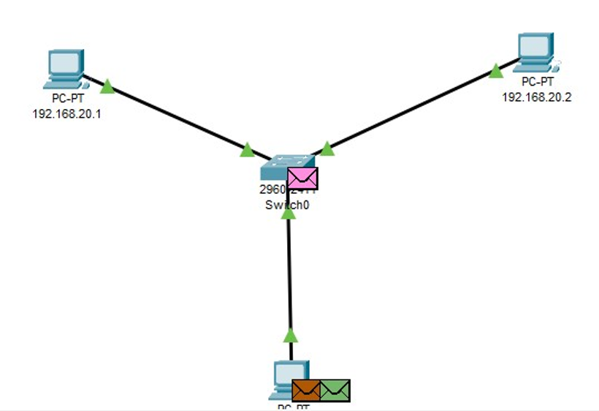

Task 4: MAC Table Check
• View switch MAC table (if available) / observe switch learning through events
